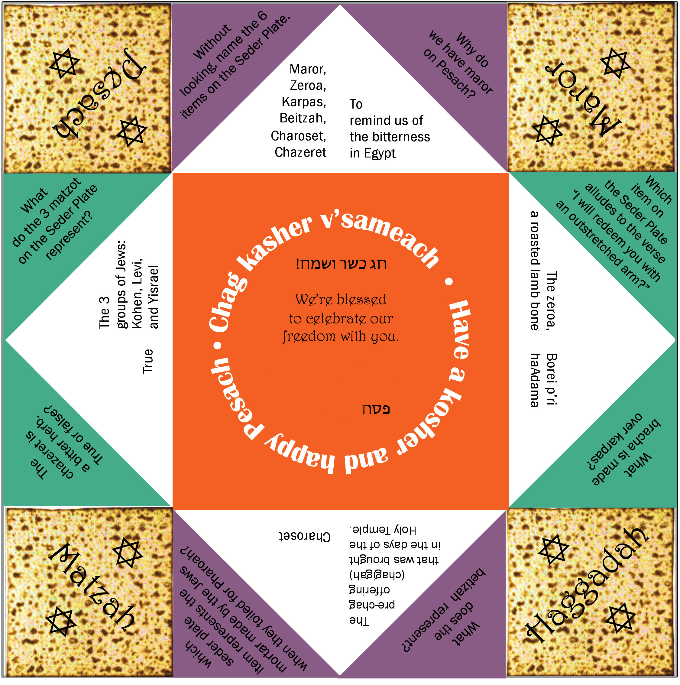

PESACH FORTUNE TELLER: Seder Plate Questions
1. Cut out the fortune teller around outside edge.
2. With printed side up, fold in half towards two opposite corners, then open up again.
Do this in both directions.
3. Turn paper printed side down. Fold each corner point to the center of the paper.
Use the creases as a guide to keep your folds straight.
4. Flip your paper over.
5. Again, fold all four corners to into the center of the paper.
6. Fold any two sides together to make a rectangle.
7. Slide your thumbs and fingers under the flaps. Enjoy!!
Concept and design: Lynn Greene
Customizing your Fortune Teller (some people call these Cootie Catchers): Add your name to the orange center: ~ The Kahn Family ~ and put year (eg, 5779/2019) to the left of .
~ The Xxxxxxx Family ~
57XX / 20XX

