A Passover Haggadah
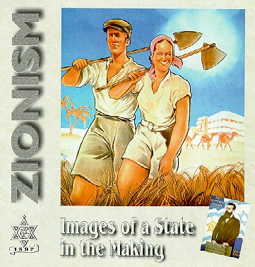
The Aliyot Seder
Huge thanks to Alan and Judy Weiss for seder concept and content, to Frederick Kaimann and Ron and Sandra Vinik for additional seder content, and Cantor Joel Caplan and Ken Avner for music. Original illustrations by Gitit Shwartz. Traditional Haggadah: Hebrew from Davka Corp., English © 1977 by Rabbi Zev Schostak. Aliyot Haggadah © 2002-2003 Alan and Judy Weiss and © 2004 Murray Spiegel

The traditional Haggadah tells the story of the exodus from Egypt to the promised land. Tonight we tell the story of the Exodus from Europe to Palestine, the First and Second Aliyot, through the establishment of the State of Israel.

The order of seder is traditionally:

Blessing 
Washing 
Vegetable 
Break middle matzah 
Recitation 
Washing 
Blessing for Matzah 
Bitter herbs 
Bitter herb sandwich 
Meal 
Eat Afikomen 
Benching 
Hallel 
Conclusion 

Kiddush 

Blessed art Thou, Lord our God, King of the Universe, Creator of the fruit of the vine.








Blessed art Thou, Lord our God, King of the Universe, who has chosen and exalted us above all nations and has sanctified us with Thy commandments. And Thou, Lord our God, has lovingly bestowed upon us appointed times for happiness, holidays and seasons for joy, this Feast of Matzah, our season of freedom, a holy convocation recalling the Exodus from Egypt. Thou did choose and sanctify us above all peoples. In Thy gracious love, Thou did grant us Thy appointed times for happiness and joy. Blessed art Thou, O Lord, who sanctifies Israel, and the appointed times.


Blessed art Thou, Lord our God, King of the Universe, who has granted us life and sustenance and permitted us to reach this season.
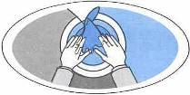
Drink the wine in a reclining position.

Washing the hands 
There is no blessing.

Karpas 
In celebration of Spring, everyone partakes of parsley, dips it into saltwater, and says:


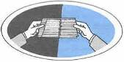
Blessed art Thou, Lord our God, King of the Universe, Creator of the fruits of the earth.

Break the middle matzah 

The leader takes the middle Matzah, breaks it in two, leaving one half between the whole ones, and puts the other half in a safe place for the grand Afikomen hunt.

Recitation 

The leader raises the dish containing the unleavened bread, while relating the story of Passover:
This is the bread of affliction which our ancestors ate in the land of Egypt. Let all who are hungry come and eat. Let all who are needy come and celebrate the Passover. At present we are here; next year may we be in Israel. At present we are slaves; next year may we be free people.
Fill the cups with wine for the Second Cup.

Tonight we begin with the following:
Everyone has moved to a new home at some point in their lives.
Describe one of your moves. Did it better your life?

Four Questions:







Four Questions in translation:

QUENYA (aka Elvish) (First Age – Third Age)
Manen lóme sina ume ve neune lómi?
Why is this night different from all other nights?
ANCIENT ARAMAIC (200 – 400 CE)
דִּבְכֻלְּהוּ לֵילָוָתָא אָכְלֵינַן חֲמִירָא וּפַטִּירָא;
בְּהָא לֵילְיָא – כֻּלֵּהּ פַּטִּירָא.
On all other nights we eat chametz and matzah;
on this night, only matzah.
MONGOLIAN (Ancient script)
On all other nights we eat all kinds of herbs;
on this night, only bitter herbs.
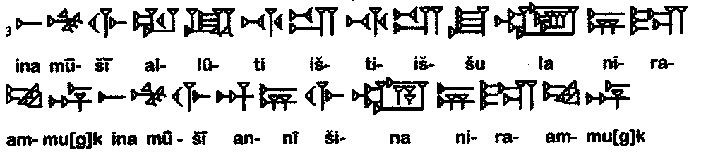
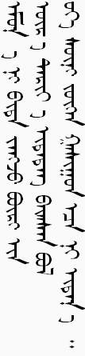
AKKADIAN (2600 BCE – 50 CE)

On all other nights we do not dip even once;
on this night, we dip twice.

OKINAWAN
常ひぃじぃや、私達や まっとぅーば 又や うちゃかてぃ いちょうびぃーしが；
今日ぬ 夜、私達や うちゃかてぃ いちょうびん。
Chinihi-ji-ya wattaha-ya mattou-ba mataya uchakati ichoubi-shiga;
chu-nu yuro- wattaha-ya uchakati ichoubin.
On all other nights we eat either sitting up or reclining;
on this night, we recline. 
...plus other recent auditions:


4 Questions translations: © Spiegel & Stein, Mah Nistanah-4 Questions Translation Project
Tonight’s new Four Questions:
What can make people leave their homes?
Why do they choose to settle in various places?
What can make some people choose to stay?
What makes a new place become home?

Europe near the turn of the century
The Pale of Settlement was created by a decree of Czar Nicholas I in April 1835 and despite minor modifications remained Russian policy until 1917 when the Bolshevik revolution removed it from the statute books. According to the census of 1897, 4,899,300 Jews lived in the Pale, forming approximately 11.6% of the total population.

Following the assassination of Alexander II by radicals in 1881, a spate of pogroms was visited upon the Jews particularly in the towns and villages of southern Russia. The number of these attacks is estimated to have been approximately 200 in 1881 alone with some forty Jews killed, many times that number were wounded and hundreds of women raped. Thousands of Jews were rendered homeless and penniless. The local authorities were particularly slow to intervene and those brought before the courts generally received very light sentences. An official investigation confirms: the plunderers were convinced that the attacks were sanctioned by the Czar himself.

To make matters worse, Alexander III passed the so-called “Temporary Laws” of May 1882 and a new period of anti-Jewish discrimination and severe persecution began. It lasted until 1917. Jews were once more prohibited from living in villages, prohibited from buying or renting property outside their prescribed residences, denied jobs in the civil service and forbidden to trade on Sundays and Christian holidays. The consequent deterioration of their economic situation led many Jews to leave Russia. By 1914, over two and one half million Jews had left the Pale, the vast majority for the United States although a small minority made their way to Eretz-Yisrael.

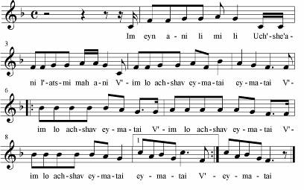
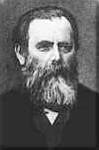
The riots convinced a number of Russian integrationist Jews that the solution to the Jewish question lay in the establishment of a Jewish national Home. One of these individuals was Leon Pinsker. Doctor and a founder and leader of the Hibbat Zion movement, he was born in Russian Poland in 1821. He inherited a strong sense of Jewish identity from his father, a Hebrew teacher and researcher. Pinsker firmly believed that the Jewish problem could be resolved if the Jews attained equal rights, but with the outbreak of anti-Jewish riots against Russian Jews in 1881, his views changed radically. He made a thorough study of Jews and Judaism, and in 1882 he anonymously published a rallying cry to Russian Jews in his German language pamphlet Autoemancipation, in which he urged the Jewish people to strive for independence, national consciousness and a return to independent territorialism. Pinsker died in Russia in 1891 and his remains were brought to Eretz-Yisrael in 1934 and reburied in Nicanor’s Cave next to Mount Scopus.

Im Eyn Ani Li:
If I am not for myself, who will be for me?
If I am only for myself, what am I?
And if not now, when?





We were slaves to Pharaoh in Egypt, but the Lord our God took us out of there with a mighty hand and an outstretched arm. Had not God taken our fathers out of Egypt, then we, our children and grandchildren would still be enslaved to Pharaoh in Egypt. Even if we all were wise, and perceptive, experienced, and versed in Torah, it would still be our duty to tell about the Exodus from Egypt. The more one talks about the Exodus, the more praise he deserves.

BETWEEN EAST AND WEST Yehuda Halevi (1080-1141)
My heart is in the East, and I myself am on the western edge. How could I enjoy drink and food! How could I ever enjoy it? Alas, how do I fulfill my promise? My sacred vow? Since Zion is still in Roman bondage, and I in Arabic bonds. All goods of Spain are chaff to my eye, but the dust on which once stood the tabernacle is gold to my eye!

The traditional Haggadah mentions Four Sons, representing four different temperaments and approaches to the Seder:
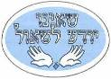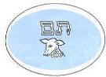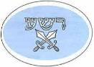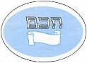



The wise child asks: What is the meaning of the testimonies, statutes, and laws which the Lord our God has commanded us? Explain to him the laws of the Pesach: that ‘no dessert may be eaten after the Passover sacrifice.’



The wicked child asks: ‘What does this service mean to you?’ By the words ‘to you’ he implies that this service is only for you, not for himself. By excluding himself from the community, he denies God. So tell him bluntly: ‘This is done on account of what the Lord did for me when I came out of Egypt.’ For me, not for him; had he been there, he would not have been redeemed.


The simple child asks: ‘What is this all about?’ Tell him, ‘With a strong hand the Lord brought us out of Egypt from the house of slavery.’


As for the child who is unable to ask a question, you must open up the subject to him, as it is written: ‘You shall tell your child on that day: This is on account of what the Lord did for me when I came out of Egypt.’

This Haggadah explores Four pioneering temperaments
Four Different Types of People
Four Different Approaches
Four Different Responses

#1 Eliezer Ben-Yehuda (1858-1922)
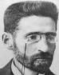
Eliezer Ben-Yehuda was born in Lithuania in 1858. Like most Jewish children of that time and place he began learning Hebrew as part of a thoroughly religious upbringing. He excelled in his studies and ultimately was sent to a yeshiva in the hope that he would become a rabbi. However, like many promising young Jews of the time in eastern Europe, he became interested in the secular world and ultimately exchanged the yeshiva for a Russian gymnasium, completing his studies in 1877. Ben-Yehuda was deeply influenced by the European concept of national fulfillment which he believed should also be applied to the Jews. He felt deeply that if the Bulgarians, who were not an ancient, classical people, could demand and obtain a state of their own, then the Jews, the People of the Book and the heirs of historic Jerusalem, deserved the same. True, Eretz-Yisrael, the land of the Jews, contained few Jews in the 19th century, and the language of the Jews, Hebrew, was virtually only a written language and not a spoken tongue, but he felt these obstacles were not insurmountable. The Jews must return to their land and begin anew to speak their own language.

Ben-Yehuda decided that he should go to Palestine. He left Russia in 1878, first going to Paris to study medicine, so as to be of future help to the Jewish community in Palestine. However, due to his own health problems, Ben-Yehuda was unable to continue his studies, yet, he did not waver in his convictions, and in 1881 he arrived in Palestine with his revival plans for the Hebrew language intact.

Ben-Yehuda wanted the Jews in Palestine to speak Hebrew exclusively. Therefore, when his first son was born in 1882, Ben-Yehuda made his wife promise to raise the boy as the first all-Hebrew speaking child in modern history. When visitors came to the house who did not know Hebrew, Ben-Yehuda would send the child to bed so that he would not hear their foreign languages. Similarly, he would not let the child listen to ‘the chirping of the birds and the neighing of horses and the fluttering of butterflies, because even they are foreign languages, at any rate not Hebrew.’ Ben Yehuda’s work included the publication of Hebrew newspapers and textbooks which were subscribed to throughout the country. He influenced the country’s teachers to make Hebrew the language of instruction in school. He began work on a modern Hebrew dictionary. It was an encyclopedia of Hebrew. He completed four volumes before his death. The remaining 13 volumes were completed by succeeding scholars and provided a basis for a revived Hebrew language. A census in 1916 indicated that 40% of the Yishuv’s population spoke Hebrew as their first language. Ben Yehuda died in Jerusalem in December 1922. 30,000 people escorted his body to its grave and Palestine Jewry observed three days of official mourning.
Ani V’Atah:
You and I will change the world, then everyone will join us. It’s been said before, but it doesn’t matter. You and I will change the world. You and I will try to start from the beginning. It’ll be tough, but so what, it doesn’t matter. You and I will change the world.
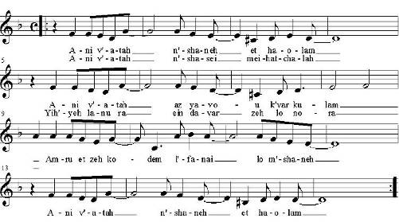

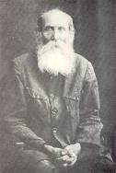
#2 Aharon David Gordon (1856-1922)
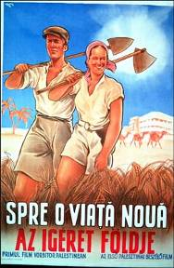
A.D. Gordon was born in 1856 in Russia to a pious family. For many years he worked managing a large tract of land which was rented out for farming. However, after working this white-collar job for 23 years, Gordon had to look for new employment at the age of 48. He decided to move to Palestine and was offered an office job there. He turned it down choosing instead to work as a manual laborer in orange groves.

Gordon believed that physical effort on the land would not only bring about his personal redemption but also that of the Jewish people. Believing that without labor the Jews would remain an island in an Arab sea, he wrote: ‘The land will not be ours and we shall not be the people of the land. Here, then, we shall also be aliens.’ He attributed to pioneer work a semi-religious status, arguing that it created an organic interrelationship between the person, the land and culture. In a famous essay he wrote: “A living people always possesses a great majority to whom labor is its second nature. Not so among us. We despise labor... There is only one path that can lead to our renaissance... the path of manual labor, of mobilizing all our national energies, of absolute and sacrificial devotion to our ideal and our tasks... Our people can be rejuvenated only if each one of us recreates himself through labor and a life close to nature.”
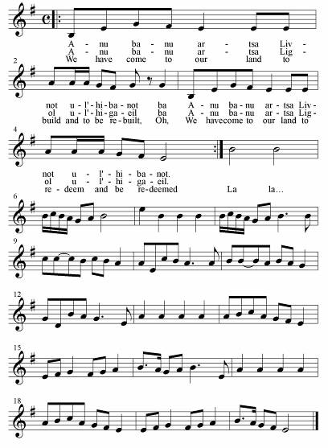
Gordon became the inspiration for a generation and more of Labor Zionists who saw in his example a way to personal and national fulfillment. A number of youth movements were influenced by his teachings and one, Gordonia, took his name as the rallying call for their work.

Gordon died in 1922 and was buried in Deganya where he had lived during his final years.

Anu Banu Artza:
We have come to our land to build and to be rebuilt,
Oh, we have come to our land to redeem and be redeemed.

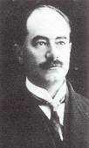
#3 Arthur Ruppin (1876-1943)
Arthur Ruppin was known as ‘the father of Zionist settlement’ and ‘the father of Jewish sociology,’ titles that reflect his two convergent careers.
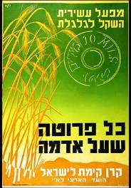
Born in Germany to an affluent family that had fallen on bad times, Ruppin at the age of 15 had to leave high school in order to get a job. He received his high school diploma in 1899, and went on to study law and economics in the university, earning a doctorate, and then working for several years in a court.

While working in law, Ruppin also launched what was to become a career in sociology, directing Berlin’s Bureau for Jewish Statistics and Demography from 1902 to 1907. His sociological research, which he began publishing in the early 1900's, strengthened Ruppin’s connection with his own Jewish roots. In 1907, he was sent by the Jewish Agency to Eretz Yisrael to assess the possibilities for Zionist settlement there; one year later he himself moved to Eretz Yisrael, settling in Jaffa and directing the Zionist Organization’s Eretz Yisrael Office, which was responsible for acquiring land and establishing Jewish settlements all over the country.

From this point on, Ruppin labored tirelessly for Jewish settlement. He became an advocate of pragmatic Zionism, believing that the most immediate need was to amass land and, through a variety of urban and rural communities, systematically settle the country and thus build a state.

Coinciding with the period of the Second Aliyah, Ruppin’s efforts affirmed the importance of Jewish labor and Jewish settlements, and offered official support to the pioneers.

In 1926, Ruppin joined the faculty of Hebrew University and taught sociology of the Jews. He combined his academic responsibilities and research with public interest work. He assisted in settling the mass of German immigrants during the Nazi rise to power, and in the absorption of Yemenite Jews. He died in Jerusalem in 1943.

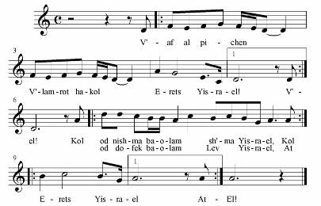

V’Af Al Pi Chen:
Nevertheless, in spite of everything, Eretz Yisrael!
As long as the Shma is heard
As long as the heart of Israel beats
So long are you the land of Israel.

Od Lo Ahavti Dai:
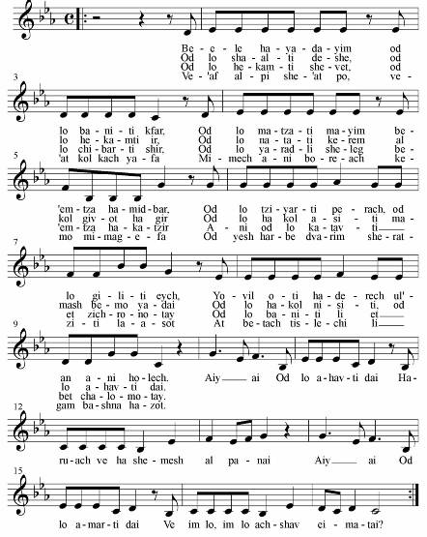
With these hands I haven’t yet build a village,
Haven’t yet found water in the middle of the wilderness,
Haven’t yet painted a flower, I haven’t yet discovered how
the path leads me and to where I am going.

Refrain
I haven’t loved enough,
The wind and sun on my face.
I haven’t said ‘enough,’
And if not now, when

Haven’t yet sowed a lawn, I haven’t raised a city.
Haven’t yet planted a vineyard on every hill of chalk.
Haven’t yet done everything with my very own hands.
Haven’t yet tried everything, I haven’t yet loved enough.

Haven’t yet raised a tribe, I haven’t composed a song yet,
Haven’t yet had snow fall for me in the middle of summer.
I haven’t yet written my memoirs,
I haven’t yet built the house of my dreams.

And even though you’re here, and you’re so very pretty,
From you I flee, as if from a plague.
There are still a lot of things that I wish to do.
You will surely forgive me this year.
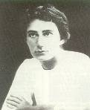
#4 Rachel (Blustein) (1890-1931)
We would wake with the dawn. A first glance at the sea. At this hour it was cast in a kind of dark slumber, framed by the blue mountains, also sleeping. One shore was ours. Every stone and cranny on it was known to us. To the right, it rose to a steep height. How many different flowers celebrated the only spring of their lives on these slopes. To the left, downcast, stood a lonely palm tree. I would dream in its shade for hours on end. The other shore, distant and strange. The expanse of the Kinneret separates us from it. The hills of the Golan, dark in the morning, bluish at noon, and wearing purple with the setting sun.

How did the day pass at the Kinneret? The dawn would see us rise for work. Blistered hands, bare feet, sunburnt and scratched, determined faces, and burning hearts. The very air rang with our song, our talk, and our laughter. The hoes rose and fell ceaselessly. For a moment you stop and wipe the sweat from your brow with the edge of your ‘kaffiah,’ steal a loving glance at the sea. How glorious. Blue, a deep blue, a bringer of peace, soothing the soul. A gull wheels above the water.

At noon we return to the farm. Still the sea is with us, its sky blue eye glancing at us through the windows of the ‘chadar ochel.’ The more Spartan the meal, the more joyful our voices. We longed to sacrifice ourselves, and by so doing to sanctify the name of the homeland.
I remember that we planted eucalyptus trees in the swamp, at the place where the Jordan divides off from the Kinneret and flows southward, flecking the rocks with its foam, and overflowing its banks. More than one of us would afterwards shake from fever on our narrow beds. But not for one moment did we cease to be thankful for our fate. The thirst was terrible. And here, one of us is sailing on the lake, on our regular ‘craft,’ an old oil-drum. What a pleasure to bend down to the gravel bed, to drink, and drink again, like an animal. To pour water on your burning face, to inhale the wind, and again to drink till the end of your strength.
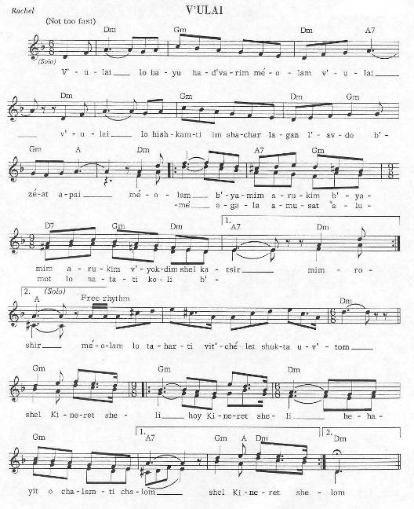

V’u Lai:
And perhaps these things never happened;
I never rose at dawn to plant the fields with my own hands;
Never did I purify myself in your azure waters;
Perhaps it was a dream,
my Kinneret.

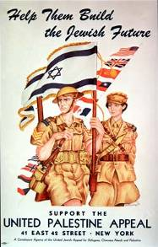



This promise has sustained our ancestors and us. For not only one enemy has risen against us to annihilate us, but in every generation men rise against us. But the Holy One, saves us from their hand.

Evils that rose up and stood in their way:

Malaria, Ottomans, British, Arabs, The Old Chalukkah system of Charity, Their Own Ignorance and Lack of Preparedness.

What did they face?

Excerpt from Mark Twain’s ‘Innocents Abroad’: (1869)

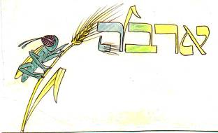
Of all the lands there are for dismal scenery, I think Palestine must be the prince. The hills are barren, they are dull of color, they are unpicturesque in shape. The valleys are unsightly deserts fringed with a feeble vegetation that has an expression about it of being sorrowful and despondent. The Dead Sea and the Sea of Galilee sleep in the midst of a vast stretch of hill and plain wherein the eye rests upon no pleasant tint, no striking object, no soft picture dreaming in a purple haze or mottled with the shadows of the clouds. Every outline is harsh, every feature is distinct, there is no perspective--distance works no enchantment here. It is a hopeless, dreary, heart-broken land.

Renowned Jerusalem itself, the stateliest name in history, has lost all its ancient grandeur, and is become a pauper village; the riches of Solomon are no longer there to compel the admiration of visiting Oriental queens; the wonderful temple which was the pride and the glory of Israel, is gone.

Things God did to help the Israelites:
The Plagues and Dayenu:
Spill a drop of wine as each plague is mentioned.

1. Blood 2. Frogs 3. Vermin 4. Wild Animals 5. Cattle Disease
6. Boils 7. Hail 8. Locusts 9. Darkness 10. Death of the Firstborn

Dayenu! Any one of God’s gifts would have been enough for us. Dayenu!
















Dayenu! How much more so, then should we be grateful to God for the numerous favors that He bestowed upon us: He brought us out of Egypt, and punished the Egyptians; He smote their gods, and slew their firstborn; He gave us their wealth and split the Sea for us; He led us through it on dry land, and sunk our foes in it; He sustained us in the desert for forty years, and fed us with the manna; He gave us the Sabbath, and brought us to Mount Sinai; He gave us the Torah, and brought us to Israel; He built the Temple for us, to atone for all our sins.

And now, a lighthearted interlude:
The Truth Behind The Passover Story
Or How the 10 Plagues Came About, A Play
© Frederick Kaimann. Minor modifications by R & M Spiegel; used and modified with permission.

Narrator assigns roles as they are read out. Cast: Narrator; Moses; God; The Angel of Death; Chief Executive Officer Angel (Angel for Falsifying Financial Statements); Chief Operating Officer Angel (Angel who is temporarily residing in Mexico); Deputy Angel (Angel for Inter-Angel Relations); Adjunct Angel (Angel for Off-Shore Incorporation); Senior Angel (Angel for Lying to Congress); Vice Angel (Angel in an Undisclosed Location); Managing Angel (Angel who turned State’s Evidence); Angel Who Only Says “What?” (aka Karen Kaplan); Angel of Divine Communication and Community Relations; Angel Named Randi.

Narrator: It has never been known how the 10 Plagues were chosen. But now transcripts from the secret meetings held at the time of the Exodus document the selection process and list plagues that did not make the final cut. This is the first time these transcripts have been published. A new chapter in the history of the children of Israel can now be written.

Scene I: On the plains outside of Egypt
(Narrator calls out the names of each speaker.)

God: (in a booming voice) I am the Lord. Tell the Pharaoh of Egypt everything I say to you. [Exodus 6:29]

Moses: (meekly) You know I am a very poor speaker, and the Pharaoh will never listen to me. [Exodus 6:30]

God: (helpful, but stern) Sounds like you need more ammo. I’ll be right back.

Scene II: Heaven

C.E.O. Angel: (businesslike) I’d like to thank everyone for coming to this emergency meeting of the Plague Selection Committee. I’ll turn it over to God for background on the situation.

God: Thank you. As you know, the children of Israel are to leave Egypt immediately. I’ve hardened the heart of the Pharaoh to resist. Moses needs some plagues to reestablish credibility. We need good plagues and fast. The floor is open to your ideas.

C.O.O. Angel: Bad hair days.

Angel Who Only Says “What?”: What?

C.O.O. Angel: All of Egypt gets incredibly bad hair days.

Senior Angel: How about sock-eating dryers. That way all of Egypt would wear only mismatched socks.

Adjunct Angel: Country music. Shania Twain, Tim McGraw – gag me.

Managing Angel: Hiccups. We shall irk them with hiccups.

Senior Angel: Are you serious?

Vice Angel: A nation of dead batteries.

Deputy Angel: Yeah, then fly everyone to Italy for 8 hours with dead DiscMans.

Senior Angel: The sound of fingernails scratching on a blackboard?

Adjunct Angel: I hate that.

C.O.O. Angel: I’ve got it, the new CBS fall lineup.

Angel Who Only Says “What?”: What?

C.O.O. Angel: All the shows are always the same. Only the actors change. Then there’s reality TV.

Adjunct Angel: Yeah, that’s not only a plague, it’s spreading. What about Men’s figure skating?

Vice Angel: I kinda like men in tights.

God: Um, I don’t mean to be critical, but these suggestions are all rather petty. In fact, these plagues are downright pathetic! You can do better.

Senior Angel: Hmm, snow on opening day casts a pall on the whole baseball season.

Adjunct Angel: So does being a Mets fan.

C.O.O. Angel: I know, all the VCRs in Egypt will flash “12:00.”

Managing Angel: God, I hate that.

God: What?

Managing Angel: Huh?

God: Did you want something?

Managing Angel: No.

God: You sure?

Managing Angel: Yeah.

God: Positive? You called me.

Managing Angel: No I didn’t. I’m fine.

C.E.O. Angel: OK, where were we?

Deputy Angel: Pop-up ads.

Angel Who Only Says “What?”: What?

Deputy Angel: You know, when you’re logged onto the Internet. “Great deals on sunny locations at Expedia.com” or “Lonely? Find that special someone at eHarmony.com.”

Adjunct Angel: I hate that.

Deputy Angel: Yeah, I always get ads for herbal Viagra. “Give your partner the pleasure she’s always wanted!” And then my mom walks in. And she’s like, “What are you looking at?” And I’m all, “No mom, it’s not what you think. I don’t need this stuff; I’m not even interested in it.”

Angel Who Only Says “What?”: (stunned) “!?”

C.E.O. Angel: Um, can we move on?

C.O.O. Angel: I know, Windows 95.

Angel Who Only Says “What?”: What?

C.O.O. Angel: All the computers in Egypt would crash all the time.

Senior Angel: We could return all email. It could say: “MAILER-DAEMON: Unable to deliver message to the following address(es)”

Managing Angel: God, that would suck.

God: Yes?

Managing Angel: What?

God: You called me.

Managing Angel: No I didn’t. Oh, forget it… (exasperated)… Jesus.

God: No, not yet. He’ll be later.

Senior Angel: Flatulence.

Adjunct Angel: Oh, that’s a good one. That’d be one smelly Egypt.

Vice Angel: Shush-ing.

C.E.O. Angel: Shush-ing?

Vice Angel: Yeah, shush-ing.

C.E.O. Angel: I don’t think that’ll go over—

Vice Angel: Shhhhhhhh!

C.E.O. Angel: —very well. Oh, I see—

Vice Angel: Zip it!

C.E.O. Angel: But the—

Vice Angel: ZIP!

Managing Angel: I’d just like to—

Vice Angel: ZIP!

God: Hey!

Vice Angel: Shhhhhhhh!

God: Now hold on a sec.—

Vice Angel: Zip it.

God: You can’t shush me! I’m God.

Vice Angel: Oops, sorry about that, your un-shush-able-ness.

God: That’s better. You know, I’m not sure we’ve reached Biblical proportions with these plagues.

C.O.O. Angel: How about a dry, itchy scalp for all of Egypt. It’d be a blizzard of dandruff.

Vice Angel: The heartbreak of psoriasis.

Managing Angel: Halitosis? It’s the reverse of flatulence.

Adjunct Angel: Splinters? Three million paper cuts?

Senior Angel: If we unleashed roaming charges and telemarketers at the same time, that’d convince Pharaoh to let the Israelites go.

Deputy Angel: Chicken.

Angel Who Only Says “What?”: What?

Deputy Angel: Chicken. McNuggets, tenders, patties. It all tastes like rubber.

Managing Angel: Bad diets. We could make all of Egypt eat a diet filled with sodium, partially-hydrogenated vegetable oil and corn syrup. Total junk food, salty snacks, candy, take-out.

Angel Named Randi: What about Matzah? Let them eat only matzah and then see what happens.

C.O.O. Angel: Food coloring. Red’s the grossest.

Senior Angel: Annoying relatives who don’t shut up.

Vice Angel: A fine mist could rain over all the land.

God: Alright, we need some resolution here. OK, some people like chicken. We’ll go with frogs. Tastes the same. I’m liking animals. Let’s call the relatives beasts. I’ll throw in some lice and cattle disease. I liked red; blood’s grosser than food coloring. And change the mist to hail.

Angel of Death: Here’s a good one, the slaying of the goldfish.

Angel Who Only Says “What?”: What?

Angel of Death: No, it’s perfect. Everyone will come home and find their goldfish floating on the top of the fish bowl.

Senior Angel: That is so lame.

Angel of Death: The slaying of the tropical fish?

Senior Angel: OK, there’s one: Lameness. There’ll be a lot of bad jokes.

God: Come on people, ramp it up. The plague of lameness has already started—here! Think big!

C.O.O. Angel: Two words: Cher.

Senior Angel: That wasn’t two words.

C.O.O. Angel: OK, bad grammar and Cher.

Senior Angel: Still wasn’t two words.

C.O.O. Angel: Gnats and Cher?

Managing Angel: We’ll permanently close the shades on all their homes.

Deputy Angel: Pokemon. Thousands of little kids running around talking about the new Picachu card. Give me a break. A sub-plague is the product tie-in.

God: OK, executive decision. Not dandruff, boils. Locusts for gnats. Instead of the curtains, darkness upon all the land. And not slaying of the goldfish, slaying of the first born. We’re talking people not pets. Any disagreement? How many do we have?

C.E.O. Angel: Ten.

God: That’s a round number. Let’s go with that. Now, the Angel of Divine Communication and Community Relations, do you have any recommendations on how to sell this?

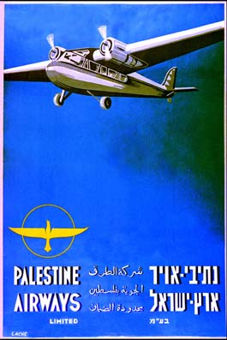
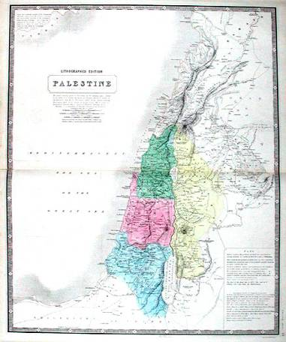
Angel of Divine Communication and Community Relations: Yes, I’ve drafted a statement for Your review that can be issued to Moses and the children of Israel under Your signature. How’s this: “When Pharaoh does not listen to you, then I will lay My hand on Egypt and bring out My hosts, My people, the children of Israel, from the land of Egypt by judgments. The Egyptians shall know that I am the Lord, when I stretch out My hand over Egypt and bring out the children of Israel from their midst.” [Exodus 7:4-5]

God: Works for me. Any objections? (pause) Hearing none, send the word out right away.

C.E.O. Angel: Unless there is any other business before this committee, we stand adjourned.

Narrator: We now return you to our regular programming, currently in progress.

Things the Chalutzim did to help themselves:
HaShomer
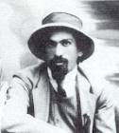
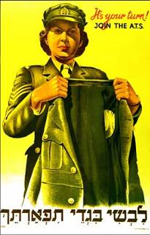
In 1907, Israel Shochat addressed a group of ten young men. He reminded the group that the Conquest of Labor also necessarily embraced the Jewish right to self-defense, the Conquest of Defense. Shochat had been traveling through the Yishuv pleading with agricultural workers to guard the lands they plowed themselves. He argued that it was unthinkable to continue hiring Arab guards to protect Jewish property and lives. This was not the way to revive the Jewish nation and the non-Jewish guards themselves were stealing from the farmers and blackmailing them. Shochat warned that if the Jews were capable now of farming their land, they should be capable of defending it. The group formed a secret society of Jewish watchmen called Bar-Giora (after the celebrated Jewish warrior of antiquity). The members of the group pledged to work as guards, speak only Hebrew and live together on a collectivist basis. When the Jewish guards tried to find employment as watchmen, however, they were turned down. They then stole a mule from under the nose of non-Jewish guards hired by the farmers. When they returned the mule in the morning, the director of the farm was convinced and hired them.

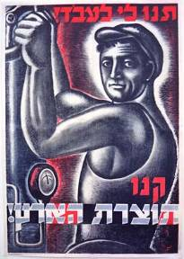
By 1909, two other villages were also convinced and began hiring the Jewish guards of Bar-Giora. Shochat and company realized they needed to expand their group. The group was renamed HaShomer, The Watchman, and set very high standards for admission. Their training program was vigorous and candidates were drilled in night maneuvers, scouting, direction finding and conversational Arabic. The members of HaShomer were known as exceptional horsemen and crack shots. After two years, the original group of eight had only increased to 26 guards for the protection of the entire Yishuv. They evoked respect among the Arabs who described them as “Moscoby”, Russians, brave men and good hunters. Soon all Lower Galilee came into HaShomer’s fold. By 1914, the group consisted of 100 men working throughout Jewish Palestine, all on instant call whenever danger threatened.

Teachers’ strike

Ben Yehuda wrote “in order to have our own land and political life it is also necessary that we have a language to hold us together. That language is Hebrew, but not the Hebrew of the rabbis and scholars. We must have a Hebrew language in which we can conduct the business of life.” Until Ben Yehuda’s efforts, the Jewish schools in Palestine taught in either Yiddish (Orthodox schools), German or French (Sephardic schools). By 1900 he had begun writing a modern Hebrew dictionary and published Hebrew newspapers and textbooks which were purchased by all the agricultural colonies. He also influenced the Yishuv’s teachers to teach in Hebrew using German and French as second languages. However, some courses and exams continued to be given only in German. Yet the issue of Hebrew versus German did not reach a crisis until 1913. In that year, funds were provided to establish a Haifa Technical Institute, The Technion. The JNF
supplied the land in Haifa and philanthropists donated additional sums. The members of the board of the Technion proposed that all technical subjects be taught exclusively in German. German was recognized as the lingua franca of science and Hebrew was deficient in technical vocabulary. The decision produced a wave of indignation among the Zionist settlers and Ben Yehuda. At Ben Yehuda’s instigation, protest meetings were organized by Jewish students and teachers throughout the Yishuv. In October 1913, the Hebrew Teachers’ Association proclaimed a strike. By February 1914, the language controversy ended when the board of the Technion reconsidered the matter and agreed that all Technion courses would be taught exclusively in Hebrew.

What else did they do?

They imported blight resistant vines and
They established training farms and
They became master gun smugglers and
They designed and built Siluqim. (What are Siluqim?)


Rabbi Gamliel used to say: 
Anyone who has not discussed these three things on Passover has not fulfilled his duty, namely:

Pesach. Matzah. Maror. 




Why did our fathers eat the Passover Offering during the period of the Temple? It is because the Holy One, Blessed be He, passed over the houses of our fathers in Egypt, as it is written: "You shall say: It is the Passover offering for the Lord, who passed over the houses of the children in Egypt when he smote the Egyptians and spared our houses. The people knelt and bowed down."

One raises the Matzah and says:




Why do we eat this matzah? It is because the King of Kings, the Holy one, revealed Himself to our fathers and redeemed them before their dough had time to ferment, as it is written: "They baked the dough which they had brought out of Egypt into unleavened cakes; for they were driven out of Egypt and could not delay, nor had they prepared any provision for their journey."

One raises the Maror and says:



Why do we eat this bitter herb? It is because the Egyptians embittered the lives of our fathers in Egypt, as it is written: "They made life bitter for them with hard labor, with clay and bricks, and with all kinds of labor in the field; whatever work tasks they performed were backbreaking."
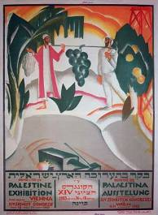
 
  
  

 
In every generation it is man's duty to regard himself as though he personally had come out of Egypt, as it is written: "You shall tell your son on that day: This is on account of what the Lord did for me when I came out of Egypt." It was not only our fathers whom the Holy One redeemed from slavery; we, too, were redeemed with them, as it is written: "He took us out from there so that He might take us to the land which He had sworn to our fathers."





Therefore it is our duty to thank and praise, pay tribute and glorify, exalt and honor, bless and acclaim the One who performed all these miracles for our fathers and for us. He took us out of slavery into freedom, out of grief into joy, out of mourning into a festival, out of darkness into a great light, out of slavery into redemption. We will recite a new song before Him! Halleluyah!





Praise the Lord! Praise, you servants of the Lord, praise the name of the Lord. Blessed be the name of the Lord from this time forth and forever. From the rising of the sun to its setting, the Lord's name is to be praised. High above all nations is the Lord; above the heavens is His glory. Who is like the Lord our God, who though enthroned on high, looks down upon heaven and earth? He raises the poor man out of the dust and lifts the needy one out of the trash heap, to seat them with nobles, with the nobles of His people. He turns the barren wife into a happy mother of children. Halleluyah!

Four more Chalutzim who shaped the nature of early Israel:

#1 Vladimir Jabotinsky (1880-1940) Zionist activist, soldier, orator, writer and poet; founder of the World War I Jewish Legion.
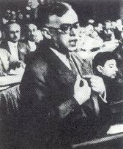
Born in Odessa, Vladimir Jabotinsky greatly influenced a large section of the Jewish people and as head of the Betar movement was the undisputed source of inspiration to many thousands of Jewish youth, particularly in Eastern Europe. His accomplished oratory – in Russian, Hebrew, Yiddish, English, French, and German – drew large audiences around the world and was often the climactic experience of Zionist Congresses.

Jabotinsky joined the editorial staff of Odesskiya Novosti, where his brilliant daily articles become widely popular. When the danger of a pogrom in Odessa seemed imminent, he joined the initiators of a Jewish self-defense group and immersed himself in Zionist activities. From 1903 through 1914,
he was the foremost Zionist lecturer and journalist in Russia. In 1909 the World Zionist Organization appointed Jabotinsky editor of four publications in Constantinople (in French, Hebrew, and Ladino) and entrusted him with political work in Ottoman circles.

While in Alexandria at the outbreak of World War I, Jabotinsky and Joseph Trumpeldor advanced the idea of a Jewish Legion joining the Allies in liberating Palestine from Ottoman rule. The first, unsatisfying, result was the Zion Mule Corps, which took part in the Gallipoli campaign. Jabotinsky went to Rome, Paris, and London to plead the case for a full-fledged Jewish Legion before Allied statesmen, but met with no sympathy. The official Zionist leadership insisted on remaining neutral in the war and condemned Jabotinsky. Finally, in 1917 the British government consented to the formation of Jewish units. The first battalion was established in England, which was joined in 1918 by two more in America and Palestine. These became the “First Judean Regiment” with the menorah as its insignia. Jabotinsky joined the 38th (British) Battalion as a lieutenant and was decorated for being the first to cross the Jordan.

Shir HaPalmach:
Though the storm is ever mounting
Still our heads remain unbowed.
We are ready to obey all commands,
The Palmach will win - we've vowed.

From Metulla to the Negev,
From the sea to the desert plain,
All our youth defend the homeland,
Till we bring it peace again.

In the eagle's path we follow,
Over mountain tracks we go,
Among stony heights and caverns,
We are seeking out the foe.

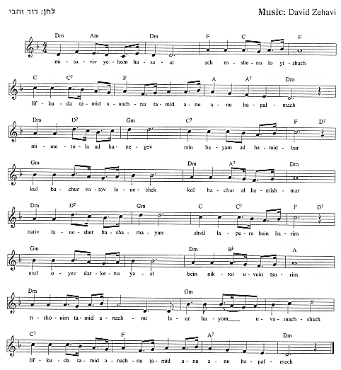
He lectured all over the world, actively collaborating on dozens of publications in many languages and drawing attention to the shortcomings of Zionist political policies and economic methods in Palestine, for which he was often accused of irresponsibility and demagoguery by the Zionist leadership. The refusal of the Zionist Congress in 1931 to accept his proposal to define the aim of Zionism as “the establishment of the Jewish State,” induced Jabotinsky to form the independent New Zionist Organization in 1935. He discussed with European governments wishing to solve the problem of their Jewish minorities, a controversial scheme for “evacuation” of 1,500,000 East European Jews to Palestine. Intent on breaking the prohibitive British regulations on immigration, Jabotinsky forcefully supported “illegal” immigration. After the Arab riots of 1936, Jabotinsky supported the
method of underground armed defense (the Haganah) and even accepted the Irgun policy of violent retaliation against the Arab population.

With the outbreak of World War II, Jabotinsky demanded the creation of a Jewish army to fight the Nazis alongside the Allied armies and a united Jewish representation at the future peace conference. In his will, written in the late 1930s, Jabotinsky said: “My remains will be transferred [to Palestine] only on the instructions of a Jewish Government.” Twenty-five years after his death, the remains of Vladimir and his wife, Johanna, were taken to Israel and buried in a state funeral on Mount Herzl.
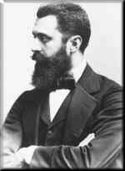
#2 Theodor Herzl (1860-1904) Visionary of Zionism
Theodor Herzl was born in Budapest in 1860. Herzl first encountered the anti-Semitism that would shape his life and the fate of twentieth century Jews while a college student at the University of Vienna. Herzl concluded anti-Semitism was a stable and immutable factor in human society, which assimilation did not solve.

He mulled over the idea of Jewish sovereignty, and published Der Judenstaat (The Jewish State, 1896). Herzl argued the essence of the Jewish problem was not individual but national. He declared that the Jews could gain acceptance in the world only if they ceased being a national anomaly. The Jews are one people, he said, and their plight could be transformed into a positive force by the establishment of a Jewish state with the consent of the great powers. He sought to deal with this in the arena of international politics.

Herzl proposed a program for collecting funds from Jews around the world to work toward realization of the goal of a Jewish state. (This organization, when eventually formed, was called the Zionist Organization.) Herzl's ideas were met with enthusiasm by the Jewish masses in Eastern Europe, although Jewish leaders and wealthy Jews such as Baron Hirsch and Baron Rothschild, refused to join the national Zionist movement. He then appealed to the people, and the result was the convening of the First Zionist Congress in Basel, Switzerland, in August, 1897.
The Congress was the first inter-territorial gathering of Jews on a national and secular basis. Its delegates declared “Zionism seeks to establish a home for the Jewish people in Palestine secured under public law.” The World Zionist Organization was established as its political arm, and Herzl was elected president.
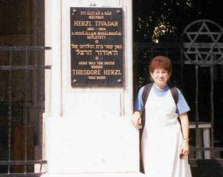
Herzl saw the need for encouragement by major powers for the aims of the Jewish people. He met with the leaders of the Ottoman Empire, Germany and Great Britain. Herzl supported, as a temporary refuge for Russian Jews, Great Britain’s proposal of Uganda, but this was rejected by the Zionist Congress.
Herzl’s birthplace, on the grounds of Budapest’s Great Synagogue.

Herzl coined the phrase “If you will it, it is no dream,” which became the motto of the Zionist movement. No one could have imagined it then, but Zionism led to the State of Israel fifty years later.

Herzl died in 1904 of pneumonia and a weak heart overworked by incessant efforts on Zionism’s behalf. By then the movement had found its place on the world political map. In 1949, Herzl's remains were reinterred on Mount Herzl in Jerusalem.
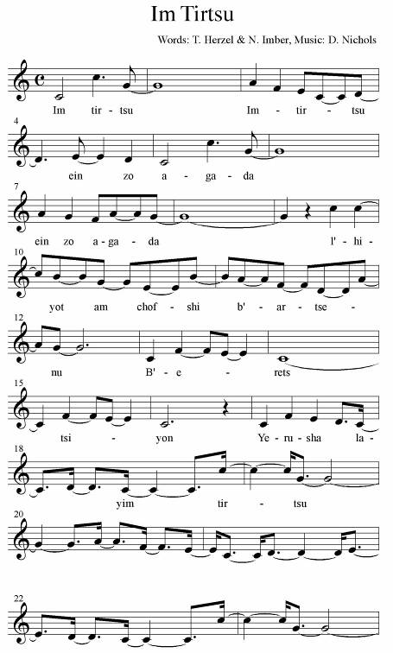

Im Tirtzu:
If you will it, it is not a dream
To be a free people in our land
In the land of Zion and Jerusalem

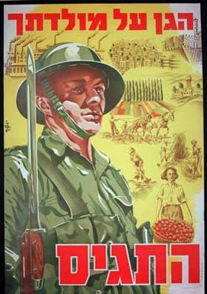




When Israel went out of Egypt, Jacob's household from a people of strange speech, Judah became God's sanctuary, Israel His kingdom. The sea saw it and fled; the Jordan turned backward. The mountains skipped like rams, and the hills like lambs. Why is it, sea, that you flee? Why, O Jordan, do you turn backward? You mountains, why do you skip like rams? You hills, why do you leap like lambs? O earth, tremble at the Lord's presence, at the presence of the God of Jacob, who turns the rock into a pond of water, the flint into a flowing fountain.






Blessed art Thou, Lord our God, King of the Universe, who hast redeemed us and our fathers from Egypt and enabled us to reach this night that we may eat matzah and maror. So Lord our God and God of our fathers, enable us to reach also the forthcoming holidays and festivals in peace, rejoicing in the rebuilding of Zion thy city, and joyful at thy service. There we shall eat of the offerings and Passover sacrifices (On Saturday night read: of the Passover sacrifices and offerings) which will be acceptably placed upon thy altar. We shall sing a new hymn of praise to Thee for our redemption and for our liberation. Blessed art Thou, O Lord, who hast redeemed Israel.

The Second Cup of Wine 


Before we drink our second cup of wine, we step briefly into the present day. Recent history and current events are filled with war. Israel experiences suicide bombings and reprisal raids on a weekly basis, Pakistan, Afghanistan and Iraq have fights with “insurgents,” and Bali, Morocco, Turkey, Saudi Arabia and now Spain have had terrorist bombings. We turn our attention to those who are often overlooked in our political discussions. Listen to last month’s (3/18/04) vote on a congressional resolution. http://www.npr.org/rundowns/segment.php?wfId=1776043
(The resolution honoring American soldiers in Iraq turned into a political fight over the Iraqi war.)
Now turn to page 39 in the Supplemental Readings for an Ode to our Soldiers.

Over the second cup of wine, one recites:

Blessed art Thou, Lord our God, King of the Universe, who createst the fruit of the vine.
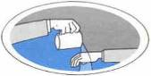
Washing 

Wash the hands for the meal:

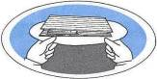
Blessed art Thou, Lord our God, King of the Universe, who hast sanctified us with thy commandments, and commanded us concerning the washing of the hands.

Blessing for Matzah 

Take the two whole matzahs and the broken one and say the following blessings:


Blessed art Thou, Lord our God, King of the Universe, who bringest forth bread from the earth.

Blessed art Thou, Lord our God, King of the Universe, who hast sanctified us with thy commandments, and commanded us concerning the eating of unleavened bread.

#3 David Ben-Gurion (1886-1973) Israel statesman; first prime minister and defense minister of Israel; headed struggle for Jewish independence in Palestine.
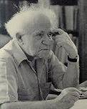
Ben-Gurion was born in Plonsk, in Russian Poland. Even from the age of 14 he was among the founders of a Zionist youth group.

After the Balfour Declaration in 1917 [first recognition of Zionist aims by a major power], Ben-Gurion was among the first to call for the formation of Jewish battalions to liberate Palestine; he later served in the Jewish Legion. He was also one of the first to propose a united workers’ movement to prepare for Jewish mass immigration and settlement after Ottoman rule. In 1921, Ben-Gurion was elected secretary-general of the Histadrut (the Trade Union movement founded in 1920) which he and Bert Katznelson headed for nearly 14 years. He was active on all levels – the organization of strikes, the struggle for the improvement of workers’ conditions, the employment of Jewish workers in the general labor market, and provision of the unemployed. The Histadut accepted Ben-Gurion’s proposal to expand to include settlement and economic activities, working on both agricultural settlement and the promotion of industry.

Ben-Gurion stressed the obligation of every member to settle in Palestine and the right of the immigrants and settlers to manage their own affairs without interference from the Diaspora. He demanded that Hebrew be the sole language of the party and of Jewish public life.
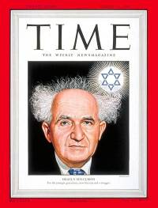
Aug 16, 1948
Ben-Gurion worked tirelessly to establish a Jewish homeland. In 1937, Ben-Gurion accepted a proposal to partition Palestine into Arab and Jewish states, believing even a small Jewish state would help realize Zionism. When this was abandoned, Ben-Gurion participated in British negotiations held with Jews and Arabs; these ended in 1939 with the declaration of Britain’s anti-Zionist policy (the White Paper). Its essentials were restrictions on aliyah and Jewish rights to acquire land.

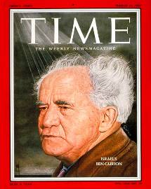
Ben-Gurion condemned the White Paper as a betrayal and called for active resistance. At the outbreak of World War II, Ben-Gurion defined the position of the Zionist movement with: “We must assist the British in the war as if there were no White Paper and we must resist the White Paper as if there were no war.”
Mar. 11, 1957

Ben-Gurion headed the War of Independence defense effort, organizing financial support, acquisition of arms, recruiting of military experts, and preparation of operational plans. During the war he molded the character and structure of the Israel Army. His opinions were decisive factors in all the events determining the borders of the Israel: the conquest of the northern Negev (October 1948), the Sinai retreat (January 1949), and the occupation of Eilat (March 1949).

When the British Mandate terminated in the spring of 1948, Ben-Gurion insisted upon the immediate establishment of the Jewish state. Ben-Gurion is best known for proclaiming the rebirth of the Jewish nation, and for being its first Prime Minister and Minister of Defense. No single party obtained an overall majority in the first elections, so Ben-Gurion
formed a coalition government, which set the pattern for future governments. In December 1949, he declared Jerusalem the capital of Israel, and its seat of government. In 1951 he launched the first Israel Bond Drive, in the United States. He gave the full weight of his authority to the Reparations Agreements with West Germany.

Ben-Gurion influenced the emergent character of the State of Israel, making the ingathering of the exiles a supreme principle; introducing free education to weld diversified elements of Israel into one nation; using the army as an educational medium; and emphasizing the advancement of science and research to develop the country and its people.

#4 Henrietta Szold (1860-1945) Zionist, philanthropist , creator of the largest Jewish organization in American history, Hadassah Women.
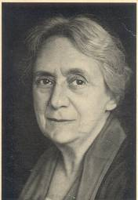
Henrietta Szold was born in Baltimore, Maryland. As the eldest of eight daughters, her father, the famous Rabbi Benjamin Szold, gave the attention and education usually reserved for an eldest son. In 1877, Henrietta Szold graduated from Western Female High School, where her record was never excelled. For nearly fifteen years she taught French, German, botany, and mathematics at the Misses Adam’s School, an elegant female academy in Baltimore. Had she been born in 1960, rather than 1860, she would probably been a rabbi. She won permission to study at the then male-only Jewish Theological Seminary, on condition that she never agitate to be granted rabbinic ordination.
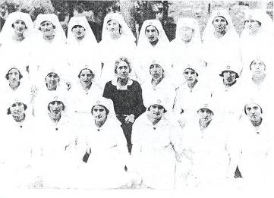
Henrietta Szold with the first graduates of the Hadassah Nursing School, Jerusalem, 1921.

Many from the influx of Russian Jews beginning in 1881 gravitated to the Szold home.
They organized a literary society where, in 1888 Henrietta Szold suggested the sponsoring of a night school for immigrants. She continued to teach and to superintend this program until 1893. By 1898, when the school was taken over by the city, it had instructed more than 5,000 pupils – Christians as well as Jews – and had become the model for what later became the predominant pattern of Americanization of immigrants.

To Henrietta Szold, Zionism was “an ideal that can be embraced by all, no matter what their attitude may be to other Jewish questions.” During her tour of the Holy Land in 1909, Henrietta Szold was as impressed by the beauty and the desirability of the land as she was by the misery and disease among the people. Upon her return she presented her ideas to her study group and two years later, invitations were issued for an organizational meeting of women interested in “the promotion of Jewish institutions and enterprises in Palestine.” On February 24, 1912, 38 women constituted what would later be called Hadassah at its first convention; Henrietta Szold was elected its first president.

Two years later, heading 1916 by then an organization of 4,000 women, Henrietta organized the American Zionist Medical Unit, consisting of doctors, nurses, administrators, vehicles, and drugs. The first year $250,000 came from the Zionist Organization, Hadassah, and the Joint Distribution Committee; the unit set
sail for Palestine June, 1918. Beginning with her trip to Palestine in February 1920, most of Henrietta’s remaining twenty-five years were spent living and working in Palestine. She became director of the unit,
and also ran the newly established Nurses’ Training School and directed health work in the Jewish schools.

In 1930 she visited the U.S., where her seventieth birthday was celebrated by Hadassah with great flourish. When Henrietta was offered an executive seat for the Va’ad Le’ummi of Palestine Jewry, she hurried back to accept the social welfare portfolio. Among many achievements were a hygiene program, the rehabilitation of juvenile delinquents, and the establishment of vocational schools.

Nazi rule accelerated German immigration to Palestine and led Henrietta to become director of the newly formed Youth Aliyah to train German children for transfer to Palestine. The first group arriving in 1934 was greeted by Henrietta Szold. Hadassah raised funds in the U.S. for Youth Aliyah and by 1935 it was supporting 1,000 children in twenty-three colonies. Despite obstacles in dealing with the British Mandate government, in acquiring immigration certificates, and in working with the Jewish communities of both Germany and Palestine, by 1948, Youth Aliya had cared for 30,000 children.


In 1934 Henrietta laid the cornerstone of the new Rothschild-Hadassah University Hospital on Mount Scopus. Ten years later, Henrietta Szold’s health was failing, and she was unable to travel to the U.S. to receive the degree of Doctor of Humanities from Boston University. It was awarded via a two-way radio broadcast. In August she contracted pneumonia and died after a prolonged stay in the hospital which she had done so much to build.

Bitter herbs 

Take some bitter herbs, dip them in Charoseth and say:

Blessed art Thou, Lord our God, King of the Universe, who hast sanctified us with thy commandments, and commanded us concerning the eating of the bitter herbs.
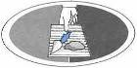
Bitter herb sandwich 

Break the undermost matzah and distribute it with some bitter herbs and charoseth, and say:


Thus did Hillel during the existence of the holy temple: he took matzah and bitter herbs, and ate them together, in order to perform the Law: "With unleavened bread and bitter herbs shall they eat it."


The Festive Meal 
Munch, munch, chew chew, drink drink, schmooze, schmooze.
Repeat until done.

Eat Afikomen 
The Leader shall inform onto the Multitudes the Sacred Rules of the Search. Upon the Finder will be bestowed Everlasting Honor and Boasting Rights. (Boasting Rights expire after two (2) years.)

Blessing after the Meal 
In World War I, a Jewish Legion made up of Jewish volunteers from many countries was organized to fight with the British against Ottoman rule over Palestine. Under General Allenby, the Jewish Legion captured Jerusalem. The Jewish fighters had their own marching song, and they sang it lustily as they entered the city. The words were from Psalm 126, sung as a song of new return.
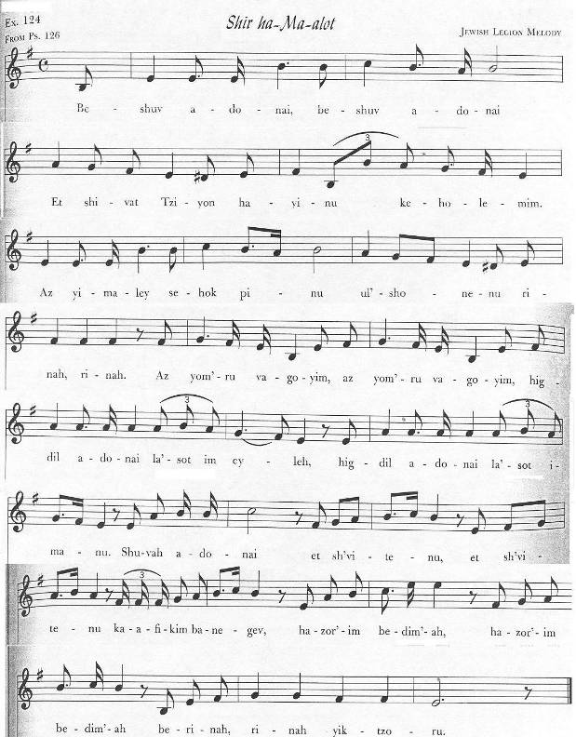

Blessings after the Meal 
Psalm 126: A Song of Ascents. When the Lord brought the exiles back to Zion, we were like those who dream. Then our mouth was filled with laughter, and our tongue with glad song. Then it was said among the nations: "The Lord has done great things for them." The Lord had done great things for us, and we rejoiced. Restore our captives, O Lord, like streams in the Negev. Those who sow in tears shall reap in joy. Though the farmer bears the measure of seed to the field in sadness, he shall come home with joy, bearing his sheaves.
Let us say grace.
Blessed be the name of the Lord from this time forth and forever.
With your permission, let us now bless our God whose food we have eaten.
Blessed be our God whose food we have eaten and through whose goodness we live.

Blessed be He and blessed be His name
Blessed art Thou, Lord our God, King of the Universe, who nourishes the whole world with grace, kindness and mercy. Thou givest food to all creatures, for thy kindness endures forever. Through this great goodness we have never been in want; may we never be in want of sustenance for His great name's sake. He is the God who sustainest all, doest good to all, and providest food for all the creatures which He hast created. Blessed art Thou, O Lord, who sustains all.

We thank Thee, Lord our God, for having given a beautiful, good, and spacious land to our fathers as a heritage; for having taken us out, Lord our God, from the land of Egypt and redeemed us from the house of slavery; thy covenant which thou hast sealed in our flesh; for thy Torah which Thou has taught us; for thy statues which Thou hast made known to us; for the life, grace and kindness Thou has bestowed on us; and for the food which Thou sustains us at all times.

For everything, Lord our God, we thank Thee and bless Thee. Be Thy name constantly blessed by all forever, as it is written: " After you have eaten and are satisfied, you shall bless the Lord your God for the good land He has given you." Blessed art thou, O Lord, for the land and the food.

Have mercy, Lord our God, on Israel thy people, on Jerusalem thy city, on Zion the abode of thy glory, on the kingdom of the house of David thy anointed one, and on the great and holy Temple that bears thy name. Our God, our Father, tend and feed us; sustained and support us and relieve us. Speedily, Lord our God, grant us relief from all our troubles. Lord our God, O make us not rely on the gifts and loans of men but rather on thy full, open and generous hand, that we may never be put to shame and disgrace.

(Favor us and strengthen us, Lord our God, with thy commandments-with the commandment concerning the seventh day, this great and holy Sabbath. This day is great and holy before Thee to abstain from work and rest on it in love according to thy will. In thy will, Lord our God, grant us rest so that there be nor sorrow and grief on our day of rest. Let us, Lord our God, live to see Zion thy city comforted, Jerusalem thy holy city rebuilt, for Thou art Master of all salvation and consolation.)

Our God and God of our fathers, may the remembrance of us, of our fathers, of the anointed son of David thy servant, of Jerusalem thy holy city, and of all thy people the house of Israel, ascend, come, appear, be heard, and be accepted before Thee for deliverance and good, for grace, kindness and mercy, for life and peace, on this day of the Feast of Matzot. Remember us this day, Lord our God, for goodness; consider us for blessing; save us for life. With a word of salvation and mercy spare us and favor us; have pity on us and save us, for we look to Thee, for Thou art a gracious and merciful God and King. Rebuild Jerusalem the holy city speedily in our days. Blessed art Thou, O Lord, who will rebuild Jerusalem in mercy. Amen.

Blessed art Thou, Lord our God, King of the Universe. God Thou art our Father, our King and Sovereign, our Creator, our Redeemer, our Maker, the Holy One of Jacob, the Shepherd of Israel, the good King who does good to all and has done good, is doing good, and will do good. Thou bestowest favors on us constantly. Thou dost ever lavish on us kindness and mercy, relief and deliverance, success, blessing, salvation, comfort, sustenance, support mercy, life and peace and all goodness. Mayest Thou never deprive us of any good thing.

May the Merciful One reign over us forever and ever.
May the Merciful One be blessed in heaven and on earth.
May the Merciful One be praised for all generations; may He be glorified in us forever and ever; may He be honored in us to all eternity.
May the Merciful One grant us an honorable livelihood.
May the Merciful One break the yoke from our neck; may He lead us upstanding into our land.
May the Merciful One send ample blessing into this house and upon this table at which we have eaten.
May the Merciful One send us Elijah the prophet of blessed memory who will bring us good tidings of consolation and comfort.
May the Merciful One bless the master of this house and the mistress of this house, and all that belongs to me and all those who are participating in this meal. May He bless us all together and all our possessions just as He blessed our forefathers Abraham, Isaac, and Jacob, with every blessing. May He bless us all together with a perfect blessing, and let us say, Amen.
May they in heaven find merits with us so that we may enjoy a lasting peace. May we receive blessings from the Lord, justice from the God of our salvation, and may we find favor and good sense in the eyes of God and men.

(May the Merciful One cause us to inherit the day which will be all Sabbath and rest in the eternal life).

May the Merciful One cause us to inherit the day of total goodness.
May the Merciful One enable us to live in the days of the Messiah and in the world to come.
He is the tower of salvation of His chosen king and shows kindness to His anointed prince, to David and his descendents forever.
He who creates peace in His heavenly heights, may He grant peace for us and for all Israel; and say, Amen.

Revere the Lord, you His holy ones for those who revere him suffer no want. Lions may be famishing and starving, but those who seek the Lord shall not lack any good thing. Give thanks to the Lord, for He is good; His kindness endures forever. Thou openest thy hand and satisfiest the desire of every living thing. Blessed is the man who trusts in the Lord, and whose trust is in the Lord. I have been young and now I am old, but never have I seen the righteous man forsaken, nor his children wanting bread. The Lord will give strength to his people; the Lord will bless His people with peace.

The Third Cup 
Blessed art Thou, Lord our God, King of the Universe, who createst the fruit of the vine.
The door is opened for Elijah:
Pour out thy wrath upon the heathen who will not acknowledge thee, and upon the kingdoms who invoke not thy name, for they have devoured Jacob, and laid waste his dwelling. Pour out thy indignation upon them, and let thy fierce anger overtake them. Pursue them in wrath and destroy them from under the heavens of the Eternal.
The door is closed and the fourth cup of wine is filled.

Hallel 
Psalm 115:1-11: Nor for our sake, O Lord, not for our sake, but for thy name's sake give glory, because of thy kindness and thy truth. Why should the nations say: "Where is their God?" Our God is in the heavens; He makes whatever He pleases! Their idols are silver and gold, the work of human hands. They have a mouth, but they cannot speak; they have eyes, but they cannot see; they have ears, but they cannot hear; they have a nose, but they cannot smell; they have hands, but they cannot feel; they have feet, but they cannot walk; nor can they utter a sound with their throat. Those who make them shall become like them, whoever trusts in them. O Israel, trust in the Lord! He is their help and shield. You who revere the Lord, trust in the Lord! He is their help and shield.

Psalm 115:12-18: The Lord who has remembered us will bless; He will bless the house of Israel; He will bless the house of Aaron; He will bless those who revere the Lord, the small with the great. May the Lord increase you, you and your children. You are blessed by the Lord, who made the heaven and earth. The heaven is the Lord's heaven, but He has given the earth to mankind. The dead cannot praise the Lord, nor can any who go down into silence. We will bless the Lord from this time forth and forever. Halleluyah!

Psalm 116:1-11: I love that the Lord hears my supplications. Because He has inclined His ear to me, I will call upon Him as long as I live. The cords of death encircled me; the pains of the grave have overtaken me; I found trouble and sorrow. Then I called upon the name of the Lord: "O Lord, save my life!" Gracious is the Lord, and righteous and our God is merciful. The Lord protects the simple; I was brought low and He saved me. Return to thy rest, O my soul, for the Lord has been kind to you. Thou hast delivered my soul from death, my eyes from tears and my feet from stumbling. I shall walk before the Lord in the lands of the living. I kept faith even when I cry out: "I am greatly afflicted.' [I kept faith even when] I said in haste: "All men are deceitful."

Psalm 116:12-19: How can I repay the Lord for all His kind acts toward me? I will raise the cup of salvations, and call upon the name of the Lord. My vows to the Lord I will pay in the presence of all His people. Precious in the sight of the Lord is the death of His pious followers. Please, O Lord, I am truly thy servant; I am thy servant, the son of thy handmaid; Thou has loosened my bonds. To Thee I sacrifice a thanksgiving offering, and call upon the name of the Lord. My vows to the Lord I will pay in the presence of all His people, in the courts of the Lord's house, in the midst of Jerusalem. Halleluyah!

Psalm 117: Give thanks to the Lord, all you nations; praise Him, all you peoples! For His kindness overwhelms us, and the truth of the Lord is forever, Halleluyah!

Psalm 118:1-4: Give thanks to the Lord, for He is good; His kindness endures forever. Let Israel say: His kindness endures forever. Let the house of Aaron say: His kindness endures forever. Let those who revere the Lord say: His kindness endures forever.

Psalm 118:5-29: From the narrows I called upon the Lord; the Lord answered me by placing me in a great expanse. The Lord is with me; I have no fear of what man can do to me. The Lord is with me among my helpers; I shall see the defeat of my foes. It is better to seek refuge in the Lord than to trust in man. It is better to seek refuge in the Lord than to trust in princes. All nations have encompassed me; but in the name of the Lord, I routed them. They swarmed around me; but in the name of the Lord, I cut them down. They swarmed like bees about me, but they were extinguished like a fire of thorns; but in the name of the Lord, I cut them down. You pushed me that I might fall, but the Lord helped me. The Lord is my strength and song; He has become my salvation. The voice of rejoicing and salvation is heard in the tents of the righteous: "The right hand of the Lord does valiantly. The Lord's right hand is raised in triumph; the Lord's right hand does valiantly!" I shall not die, but live to relate the deeds of the Lord. The Lord has surely punished me, but He has not left me to die. Open for me the gates of righteousness, that I may enter and praise the Lord. This is the gate of the Lord; the righteous may enter through it.

I thank Thee for Thou has answered me and have become my salvation.
The stone which the builders rejected has become the major cornerstone.
This the Lord's doing; It is marvelous in our eyes.
This is the day which the Lord has made; We will be glad and rejoice on it.
O Lord, please save us! O Lord, please save us!
O Lord, let us prosper! O Lord, let us prosper!

Blessed be he who comes in the name of the Lord;
We bless you from the house of the Lord.
The Lord is God who has shown us light;
Bind the sacrifice with cords, up to the altar-horns.
Thou art my God, and I thank Thee;
Thou art my God, and I exalt Thee.
Give thanks to the Lord, for He is good;
His kindness endures forever.

Psalm 136: Give thanks to the Lord, for He is good,
His kindness endures forever; 
Give thanks to the God above gods, 
Give thanks to the Lord of lords, 
To Him who alone does great wonders, 
To Him who made the heavens with understanding, 
To Him who stretched the earth over the waters, 
To Him who made the great lights, 
The sun to reign by day, 
The moon and the stars to reign by night, 
To Him who smote Egypt in their firstborn, 
And took Israel out from among them, 
With strong hand and outstretched arm, 
To him who parted the Red Sea, 
And caused Israel to pass through it, 
And threw Pharaoh and his host in the Red Sea, 
To Him who led His people through the wilderness, 
To Him who smote great kings, 
And slew mighty kings, 
Sihon, king of the Amorites, 
And Og, king of Bashan, 
And gave their land as an inheritance, 
An inheritance to Israel His servant, 
Who remembered us in our low state, 
And released us from our foes, 
Who gives food to all creatures, 
Give thanks to God of all heaven, 

The soul of every living being shall bless thy name, Lord our God the spirit of all flesh shall ever glorify and exalt thy remembrance, our King. Throughout eternity Thou art God. Besides Thee we have no king who redeems and saves, ransoms and rescues, sustains and shows mercy in all times of trouble and distress. We have no King but Thee-God of the first and of the last, God of all creatures, Master of all generations, One acclaimed with a multitude of praises, He who guides His world with kindness and His creatures with mercy. The Lord neither slumbers nor sleeps; He rouses those who sleep and wakens those who slumber; He enables the speechless to speak and loosens the bonds of the captives; He supports those who are fallen and raises those who are bowed down. To Thee alone we give thanks.

Were our mouth filled with song as the ocean, and our tongue with joy as the endless waves; were our lips full of praise as the wide heavens, and our eyes shining like the sun or the moon; were our hands spread out in prayer as the eagles of the sky and our feet running as swiftly as the deer--we should still be unable to thank Thee and bless thy name, Lord our God and God of our fathers, for one of the thousands and even myriads of favors which Thou hast bestowed on our fathers and on us. Thou hast liberated us from Egypt, Lord our God, and redeemed us from the house of slavery. Thou has fed us in famine and sustained us with plenty. Thou hast saved us from the sword, helped us to escape the plague, and spared us from severe and enduring diseases. Until now Thy mercy has helped us, and Thy kindness has not forsaken us; mayest Thou, Lord our God, never abandon us.

Therefore, the limbs which Thou has given us, the spirit and soul which Thou has breathed into our nostrils, and the tongue which Thou hast placed in our mouth, shall all thank and bless, praise and glorify, exalt and revere, sanctify and acclaim thy name, our King. To Thee, every mouth shall offer thanks; every tongue shall vow allegiance; every knee shall bend, and all who stand erect shall bow. All hearts shall revere Thee, and men's inner beings shall sing to thy name, as it is written: "all my bones shall say: O Lord, who is like Thee? Thou savest the poor man from one that is stronger, the poor and needy from one who would rob him." Who may be likened to Thee? Who is equal to Thee? Who can be compared to Thee? O Great, mighty and revered God, supreme God is the Master of heaven and earth. Let us praise, acclaim and glorify Thee and bless thy holy name, as it is said: "A Psalm of David: Bless the Lord, O my soul, and let my whole inner being bless His holy name."

O God in thy mighty acts of power, great in the honor of thy name, powerful forever and revered for thy awe-inspiring acts, O King seated upon a high and lofty throne!

He who abidest forever, exalted and holy is His name. And it is written: "Rejoice in the Lord, you righteous; it is pleasant for the upright to give praise." By the mouth of the upright you shall be praised; By the words of the righteous you shall be blessed; By the tongue of the pious you shall be exalted; And in the midst of the holy you shall be sanctified.

In the assemblies of the multitudes of thy people, the house of Israel, with song shall thy name, our King, be glorified in every generation. For it is the duty of all creatures to thank, praise, laud, extol, exalt, adore, and bless Thee; even beyond the songs and praises of David the son of Jesse, thy anointed servant.

Praise be thy name forever, our King, who rules and is great and holy in heaven and on earth; for to Thee, Lord our God, it is fitting to render song and praise, hallel and psalms, power and dominion, victory, glory and might, praise and beauty, holiness and sovereignty, blessings and thanks, from now and forever.

All thy works praise Thee, Lord our God; thy pious followers who perform thy will, and all thy people the house of Israel, praise, thank, bless, glorify, extol, exalt, revere, sanctify, and coronate thy name, our King. To Thee it is fitting to give thanks, and unto thy name it is proper to sing praises, for Thou art God eternal.
Ki Lo NaEh 






To Him, praise is becoming. To Him, praise will always be becoming.

Next year in Jerusalem! 

The fourth cup 


Blessed art Thou, Lord our God, King of the Universe, who creates the fruit of the vine.










Blessed, art Thou, Lord our God, King of the Universe, for the vine and its fruit, and for the produce of the field, for the beautiful and spacious land which Thou gave to our fathers as a heritage to eat of its fruit and to enjoy its goodness. Have mercy, Lord our God, on Israel thy people, on Jerusalem thy city, on Zion the abode of thy glory, on thy altar and thy Temple. Rebuild Jerusalem, the holy city, speedily in our days. Bring us there and cheer us with its restoration; may we eat of its fruit and enjoy of its goodness; may we bless Thee for it in holiness and purity. (Favor us and strengthen us on this Sabbath day) and grant us happiness on this Feast of Matzot; For Thou, O Lord, are good and beneficent to all, and we thank Thee for the land and the fruit of the vine. Blessed art Thou, O Lord for the land and the fruit of the vine.

Acceptance of the Seder 




The Seder of Passover has now been accomplished according to its order, all the ordinances and customs of the feast. Just as we were privileged to arrange it tonight, So may we be granted to perform it again. O Most Holy who dwellest in the heights above, Establish us as a countless people once again, Speedily guide thy plants Israel as a redeemed people, To the land of Zion with song.

This is the first day of the Omer 
Second night, say:





May it be thy will, O Eternal, our God, and the God of our ancestors, speedily rebuild thy temple in our days, and grant us our share in thy Law.

A Dear Who? 
A 15th C. poem/song.




















Echad Mi Yodea 
Based on a 15th-16th C. folksong.























































Chad Gadya, Chad Gadya 
Added to the Haggadah in the 15th-16th C.




































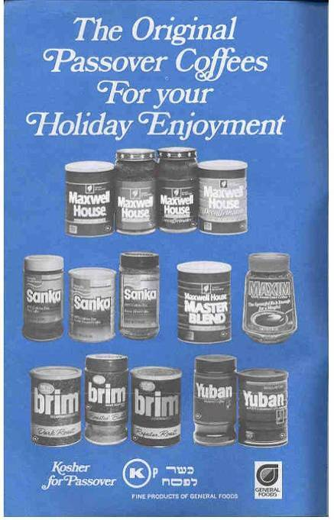
In Larry D's honor







Leader: 

Leader: 




















































































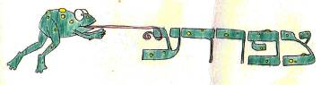



































































































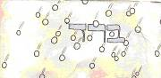

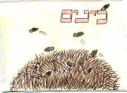

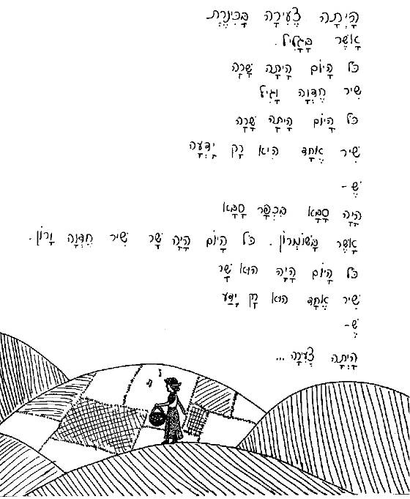
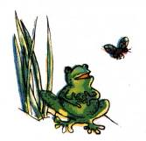
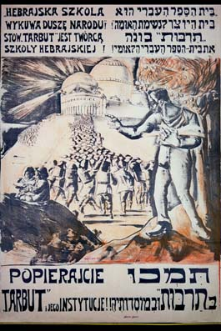

SUPPLEMENTAL READINGS

http://www.us-israel.org/jsource/Immigration/First_Aliyah.html, Second_Aliyah.html, etc
The First Aliyah
The First Aliyah followed pogroms in Russia in 1881-1882, with most of the immigrants coming from Eastern Europe; a small number also arrived from Yemen. Members of Hibbat Zion and Bilu, two early Zionist movements that were the mainstays of the First Aliyah, defined their goal as "the political, national, and spiritual resurrection of the Jewish people in Palestine."
Though they were inexperienced idealists, most chose agricultural settlement as their way of life and founded the moshav movement — farmholders' villages based on the principle of private property. Three early villages of this type were Rishon Lezion, Rosh Pina, and Zikhron Ya'akov.
The First Aliyah settlers encountered many difficulties, including an inclement climate, disease, crippling Turkish taxation and Arab opposition. They required assistance and received scanty aid from Hibbat Zion, and more substantial aid from Baron Edmond de Rothschild. He provided the moshavot with his patronage and the settlers with economic assistance, thereby averting the collapse of the settlement enterprise. The Yemenite olim, most of whom settled in Jerusalem, were first employed as construction workers and later in the citrus plantations of the moshavot.
In all, nearly 35,000 Jews came to Palestine during the First Aliyah. Almost half of them left the country within several years of their arrival, some 15,000 established new rural settlements, and the rest moved to the towns.

The Second Aliyah
The Second Aliyah (1904-1914), in the wake of pogroms in Czarist Russia and the ensuing eruption of anti-Semitism, had a profound impact on the complexion and development of modern Jewish settlement in Palestine. Most of its members were young people inspired by socialist ideals. Many models and components of the rural settlement enterprise came into being at this time, such as "national farms" where rural settlers were trained; the first kibbutz, Degania (1909); and Ha-Shomer, the first Jewish self-defense organization in Palestine. The Ahuzat Bayit neighborhood, established as a suburb of Jaffa, developed into Tel Aviv, the first modern all-Jewish city. The Hebrew language was revived as a spoken tongue, and Hebrew literature and Hebrew newspapers were published. Political parties were founded and workers' agricultural organizations began to form. These pioneers laid the foundations that were to put the yishuv (the Jewish community) on its course toward an independent state.
In all, 40,000 Jews immigrated during this period, but absorption difficulties and the absence of a stable economic base caused nearly half of them to leave.

The Third Aliyah
This aliyah (1919-1923), a continuation of the Second Aliyah (which was interrupted by World War I), was triggered by the October Revolution in Russia, the ensuing pogroms there and in Poland and Hungary, the British conquest of Palestine and the Balfour Declaration. Most members of the Third
Aliyah were young halutzim (pioneers) from Eastern Europe. Although the British Mandatory regime imposed aliyah quotas, the yishuv numbered 90,000 by the end of this period. The new immigrants built roads and towns, and projects such as the draining of marshes in the Jezreel Valley and the Hefer Plain were undertaken. The General Federation of Labor (Histadrut) was established, representative institutions for the yishuv were founded (the Elected Assembly and the National Council), and the Haganah (the clandestine Jewish defense organization) was formed. Agricultural settlement expanded, and the first industrial enterprises were established.
Approximately 40,000 Jews arrived in Palestine during the Third Aliyah; relatively few returned to their countries of origin.

The Fourth Aliyah
The Fourth Aliyah (1924-1929) was a direct result of the economic crisis and anti-Jewish policies in Poland, along with the introduction of stiff immigration quotas by the United States. Most of the immigrants belonged to the middle class and brought modest sums of capital with which they established small businesses and workshops. Tel Aviv grew. Notwithstanding the yishuv's economic woes, with an economic crisis in 1926-1928, the Fourth Aliyah did much to strengthen the towns, further industrial development and reinstate Jewish labor in the villages.
In all, the Fourth Aliyah brought 82,000 Jews to Palestine, of whom 23,000 left.

The Fifth Aliyah
The signal event of this Fifth aliyah wave (1929-1939) was the Nazi accession to power in Germany (1933). Persecution and the Jews' worsening situation caused aliyah from Germany to increase, and aliyah from Eastern Europe to resume. Many of the immigrants from Germany were professionals; their impact was to be felt in many fields of endeavor. Within a four-year period (1933-1936), 174,000 Jews settled in the country. The towns flourished as new industrial enterprises were founded and construction of the Haifa port and the oil refineries was completed. Throughout the country, "stockade and tower" settlements were established. During this period in 1929 and again in 1936-39 violent Arab attacks on the Jewish population took place, called "disturbances" by the British. The British government imposed restrictions on immigration, resulting in Aliyah Bet — clandestine, illegal immigration.
By 1940, nearly 250,000 Jews had arrived during the Fifth Aliyah (20,000 of them left later) and the yishuv's population reached 450,000. From this time on, the practice of "numbering" the waves of immigration was discontinued, which is not to say that aliyah had exhausted itself.

The Betar Movement
http://www.wzic.org/Betar.html

The Betar Movement was founded in 1923 in Riga, Latvia, by Zionist leader Ze'ev Jabotinsky. The Movement quickly established a reputation as the premier activist Zionist youth organization, a position that it has maintained to this day. Betar members played vital roles in the struggle against the British Mandate and the establishment of the State of Israel.
Many of Israel's most prominent public figures have been graduates of the Movement, including former Prime Ministers Menachem Begin and Yitzhak Shamir and former Defense Minister Moshe Arens.
Today, the Betar Movement is primarily involved in Jewish and Zionist education and activism and has chapters worldwide.

The Balfour Declaration
During the First World War, British policy became gradually committed to the idea of establishing a Jewish home in Palestine. After discussions in the British Cabinet, and consultation with Zionist leaders, the decision was made known in the form of a letter by Arthur James Lord Balfour to Lord Rothschild. The letter represents the first political recognition of Zionist aims by a major power.
Foreign Office
November 2nd, 1917
Dear Lord Rothschild,
I have much pleasure in conveying to you, on behalf of His Majesty's Government, the following declaration of sympathy with Jewish Zionist aspirations which has been submitted to, and approved by, the Cabinet.
"His Majesty's Government view with favour the establishment in Palestine of a national home for the Jewish people, and will use their best endeavours to facilitate the achievement of this object, it being clearly understood that nothing shall be done which may prejudice the civil and religious rights of existing non-Jewish communities in Palestine, or the rights and political status enjoyed by Jews in any other country."
I should be grateful if you would bring this declaration to the knowledge of the Zionist Federation.

Yours sincerely,
Arthur James Balfour

Owed to Our Soldiers
by Ron and Sandra Vinik; Used by Permission

At the Passover Seder, we celebrate our deliverance from bondage and oppression. We repeat the saga of attaining our freedom from Egyptian slavery. Traditionally the Exodus narrative is told from the perspective of the victims, the Israelites. This year, rather than focusing on the liberated people, we want to pay tribute to the liberators, the soldiers who bring freedom to the oppressed. So we wrote this “ode” to our soldiers to recognize what we owe to them.

Our liberty derives from their sacrifice: of their homes, of their families, of their limbs and even of their lives. Their very presence ensures our liberty. This year we initiated a war against the Iraqi regime of Saddam Hussein. Many of us have ambivalence regarding this war—the international community and many loyal Americans opposed the war. We were presented with various rationales for this pre-emptive offensive. Were the reasons altruistic, to deliver the oppressed Iraqi people from a tyrannical regime? Or was the war waged for our own protection? Or even was it fought for economic advantage?

What does our Jewish tradition tell us about waging war on other nations? Is there a moral defense? Well, Jewish history reveals the same ambivalence that we face today. Our freedom from the tyranny of the Pharaoh was bought at the expense of the Egyptian population and the Egyptian army. The plagues were a series of ecological disasters culminating in the deaths of the innocent first-born of each Egyptian family. Finally, the Egyptian army was drowned in the Sea of Reeds. This was the price paid for our freedom, and the Israelites attributed it to the will of God. God then instructed the Israelites to settle in the Promised Land, but that involved decimating the Canaanites and other idolatrous tribes that did not worship the God of Israel.

Later in our history, we were subjugated to the Greeks and Romans, who had far greater numbers and mighty armies. The Maccabees offered a token resistance to the Greek yoke, but they were totally outnumbered and crushed. Rabbinical thought rationalized that Jews should take a pacifist role, and Jews adopted that mindset for hundreds of years. As a result, Jews suffered generations of persecution: the Spanish Inquisition, ghettoes, pogroms and finally the Holocaust. Our experience has taught us that war is a necessary evil, and that our survival as Jews and as Americans depends on our ability to fight, and to fight back.

Now that Saddam Hussein is gone and Iraq is in ruins, where do we stand? We will not know until sufficient time has passed and we have the perspective of history to judge these events. So tonight, on Passover, we should remember and pay tribute not only to the Iraqi people, the innocent victims of Saddam, but also to all soldiers. The soldiers do not have the luxury of ambivalence nor the right to debate the issue. They do as they are commanded. While the soldiers prosecute war, they also maintain the peace, keep order and preserve justice. They put their lives on the line for the cause of freedom, and on this night we pause to recognize them and acknowledge that we owe our liberty to their sacrifice.

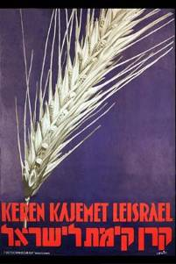
The Chalukkah system of charity essentially made chalutzim dependent on the charity of others, rather than be self-sufficient. It was partially financed by Baron Rothschild. It was perceived by the leaders of the Second Aliyah as the main reason the First Aliyah was generally a failure.
Siluqim were the underground weapons caches. Judy Weiss has a shirt saying "Don't talk about it" - she had visited one of these places while on a tour with Friends of the IDF.

Israel’s Declaration of Independence

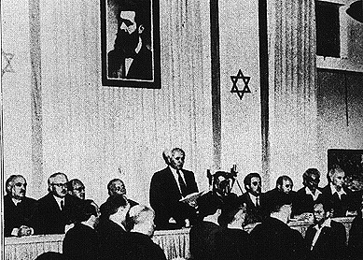

The proclamation of the State of Israel, May 14, 1948, in Tel Aviv. David Ben-Gurion is flanked by the members of his provisional government, including (left to right) Bechor Shitreet, David Remez, Pinchas Rosen, Perez Naftali, Rabbi Y.L. Maimon (Rishman), Moshe Shapiro (behind microphone), Moshe Sharett, Eliezer Kaplan, Mordekhai Bentov and Aharon Zisling.

ERETZ-YISRAEL [The Land of Israel, Palestine] was the birthplace of the Jewish people. Here their spiritual, religious and political identity was shaped. Here they first attained to statehood, created cultural values of national and universal significance and gave to the world the eternal Book of Books.
After being forcibly exiled from their land, the people kept faith with it throughout their Dispersion and never ceased to pray and hope for their return to it and for the restoration in it of their political freedom.
Impelled by this historic and traditional attachment, Jews strove in every successive generation to re-establish themselves in their ancient homeland. In recent decades they returned in their masses. Pioneers, ma’pilim [immigrants coming to Eretz-Yisrael in defiance of restrictive legislation] and defenders, they made deserts bloom, revived the Hebrew language, built villages and towns, and created a thriving community controlling its own economy and culture, loving people but knowing how to defend itself, bringing the blessings of progress to all the country’s inhabitants, and aspiring towards independent nationhood.
In the year 5657 (1897), at the summons of the spiritual father of the Jewish State, Theodore Herzl, the First Zionist Congress convened and proclaimed the right of the Jewish people to national rebirth in its own country.
This right was recognized in the Balfour Declaration of the 2nd November, 1917, and reaffirmed in the Mandate of the League of Nations which, in particular, gave international sanction to the historic connection between the Jewish people and Eretz-Yisrael and to the right of the Jewish people to rebuild its National Home.
The catastrophe which recently befell the Jewish people – the massacre of millions of Jews in Europe – was another clear demonstration of the urgency of solving the problem of its homelessness by re-establishing in Eretz-Yisrael the Jewish State, which would open the gates of the homeland wide to every Jew and confer upon the Jewish people the status of a fully privileged member of the comity of nations.
Survivors of the Nazi holocaust in Europe, as well as Jews from other parts of the world, continued to migrate to Eretz-Yisrael, undaunted by difficulties, restrictions and dangers, and never ceased to assert their right to a life of dignity, freedom and honest toil in their national homeland.
In the Second World War, the Jewish community of this country contributed its full share to the struggle of the freedom- and peace-loving nations against the forces of Nazi wickedness and, by the blood of its soldiers and its war effort, gained the right to be reckoned among the peoples who founded the United Nations.
On the 29th November, 1947, the United Nations General Assembly passed a resolution calling for the establishment of a Jewish State in Eretz-Yisrael; the General Assembly required the inhabitants of Eretz-Yisrael to take such steps as were necessary on their part for the implementation of that resolution. This recognition by the United Nations of the right of the Jewish people to establish their State is irrevocable.
This right is the natural right of the Jewish people to be masters of their own fate, like all other nations, in their own sovereign State.
ACCORDINGLY WE, MEMBERS OF THE PEOPLE’S COUNCIL, REPRESENTATIVES OF THE JEWISH COMMUNITY OF ERETZ-YISRAEL AND OF THE ZIONIST MOVEMENT, ARE HERE ASSEMBLED ON THE DAY OF THE TERMINATION OF THE BRITISH MANDATE OVER ERETZ-YISRAEL AND, BY VIRTUE OF OUR NATURAL AND HISTORIC RIGHT AND ON THE STRENGTH OF THE RESOLUTION OF THE UNITED NATIONS GENERAL ASSEMBLY, HEREBY DECLARE THE ESTABLISHMENT OF A JEWISH STATE IN ERETZ-YISRAEL, TO BE KNOWN AS THE STATE OF ISRAEL.
WE DECLARE that, with effect from the moment of the termination of the Mandate being tonight, the eve of Sabbath, the 6th Iyar, 5708 (15th May, 1948), until the establishment of the elected, regular authorities of the State in accordance with the Constitution which shall be adopted by the Elected Constituent Assembly not later than the 1st October, 1948, the People’s Council shall act as a Provisional Council of State, and its executive organ, the People’s Administration, shall be the Provisional Government of the Jewish State, to be called “Israel.”
THE STATE OF ISRAEL will be open for Jewish immigration and for the Ingathering of the Exiles; it will foster the development of the country for the benefit of all its inhabitants; it will be based on freedom, justice and people as envisaged by the prophets of Israel; it will ensure complete equality of social and political rights to all its inhabitants irrespective of religion, race or sex; it will guarantee freedom of religion, conscience, language, education and culture; it will safeguard the Holy Places of all religions; and it will be faithful to the principles of the Charter of the United Nations.
THE STATE OF ISRAEL is prepared to cooperate with the agencies and representatives of the United Nations in implementing the resolution of the General Assembly of the 29th November, 1947, and will take steps to bring about the economic union of the whole of Eretz-Yisrael.
WE APPEAL to the United Nations to assist the Jewish people in the building-up of its State and to receive the State of Israel into the comity of nations.
WE APPEAL – in the very midst of the onslaught launched against us now for months – to the Arab inhabitants of the State of Israel to preserve peace and participate in the upbuilding of the State on the basis of full and equal citizenship and due representation in all its provisional and permanent institutions.
WE EXTEND our hand to all neighbouring states and their people in an offer of peace and good neighbourliness, and appeal to them to establish bonds of cooperation and mutual help with the sovereign Jewish people settled in its own land. The State of Israel is prepared to do its share in a common effort for the advancement of the entire Middle East.
WE APPEAL to the Jewish people throughout the Diaspora to rally round the Jews of Eretz-Yisrael in the tasks of immigration and upbuilding and to stand by them in the great struggle for the realization of the age-old dream – the redemption of Israel.
PLACING OUR TRUST IN THE ALMIGHTY, WE AFFIX OUR SIGNATURES TO THIS PROCLAMATION AT THIS SESSION OF THE PROVISIONAL COUNCIL OF STATE, ON THE SOIL OF THE HOMELAND, IN THE CITY OF TEL-AVIV, ON THE SABBATH EVE, THE 5TH DAY OF IYAR, 5708 (14TH MAY, 1948).
David Ben-Gurion
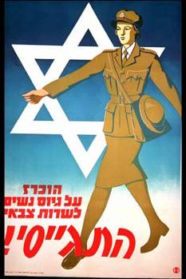

Daniel Auster
Mordekhai Bentov
Yitzchak Ben-Zvi
Eliyahu Berligne
Perez (Fritz) Bernstein
Rachel Cohen
Eliyahu Dobkin
Rabbi Wolf Gold
Meir Grabovsky (Argov)
Abraham Granott (Granovsky)
Yitzchak Gruenbaum
Rabbi Kalman Kahana
Eliezer Kaplan
Sa’adia Kobashi
Moshe Kol (Kolodny)
Rabbi Yitzchak Meir Levin
Meir David Loewenstein
Zvi Lurie
Rabbi Yehuda Leib Maimon (Fishman)
Golda Meir (Myerson)
Nachum Nir-Rafalkes
Avraham Nissan (Katznelson)
David Zvi Pinkas
Moshe David Remez
Berl Repetur
Pinhas Rosen (Felix Rosenblueth)
Zvi Segal
Moshe (Hayyim) Shapira
Moshe Sharret (Shertok)
Mordechai Shattner
Behor Shalom Shitreet
Ben-Zion Sternberg
Meir Vilner-Kovner
Zerach Warhaftig
Herzl Vardi
Aharon Zisling

